國中教育會考英語科聽力測驗模擬試題 (1)

本測驗符合「國中教育會考」英語科聽力測驗題型，請掃描 QR code 進行測驗。

第一部分：辨識句意
作答說明：
第1-3題每題均有三個選項，請依據所聽到的單句，選出符合描述的圖表。

____ 1.
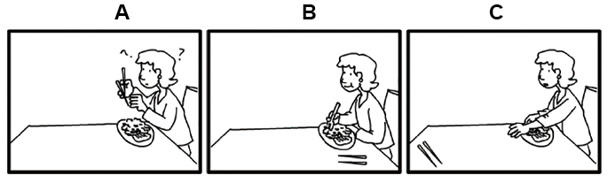
____ 2.
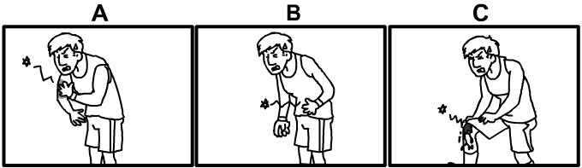
____ 3.
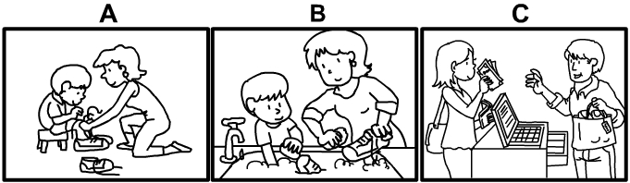

第二部分：基本問答
作答說明：
第4-9題每題均有三個選項，請依據所聽到的對話問句，選出一個最適合的回答。

____ 4.
(A) Yes, he runs really fast.
(B) Yes, he gets angry easily.
(C) Yes, he is not proud.
____ 5.
(A) Cool! I love to walk in the woods.
(B) OK, there’s a new movie out today.
(C) Sure, we can do some shopping.
____ 6.
(A) What? Who ate them all?
(B) Good. I’ll have some after lunch.
(C) You’re wrong. Chocolate is not my favorite.
____ 7.
(A) Yes, I just lost my wedding ring.
(B) Yes, I really enjoy watching movies.
(C) Yes, I have to study for the math test.
____ 8.
(A) OK, let’s spend time alone.
(B) Sure, I feel tired as well.
(C) OK, I’ll invite some people.
____ 9.
(A) Yes, it will get colder.
(B) Yes, it will stay the same.
(C) Yes, it’s going to get hotter.

第三部分：言談理解
作答說明：
第10-15題每題均有三個選項，請依據所聽到的對話或短文內容，選出一個最適合的答案。

____ 10.
(A) She doesn’t want to wait.
(B) She doesn’t want to go to the party.
(C) She loves to take the bus.
____ 11.
(A) Answers for the English exam.
(B) Some ideas for learning English.
(C) A famous English book.
____ 12.
(A) They should eat something.
(B) They should visit the museum right away.
(C) They should take a picture in front of the museum.
____ 13.
(A) He gave Susan a kiss.
(B) He invited Susan to a party.
(C) He gave Susan a gift.
____ 14.
(A) She will ask the man to feed the cat.
(B) She will feed the cat when she can.
(C) She will pick up the cat later.
____ 15.
(A) How to improve your sleep.
(B) How to include exercise in your daily plan.
(C) How to keep a healthy way of living.

