國中教育會考英語科聽力測驗模擬試題 (2)

本測驗符合「國中教育會考」英語科聽力測驗題型，請掃描 QR code 進行測驗。

第一部分：辨識句意
作答說明：
第1-3題每題均有三個選項，請依據所聽到的單句，選出符合描述的圖表。

____ 1.
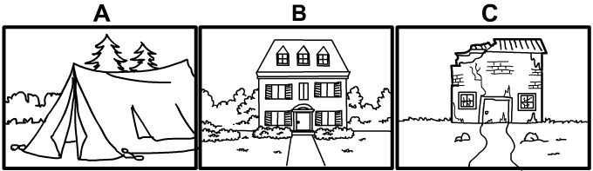
____ 2.
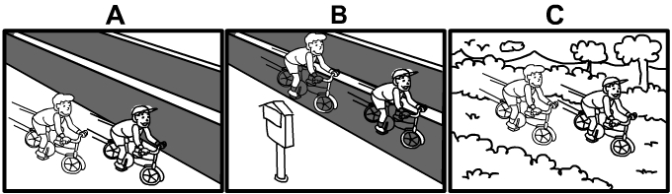
____ 3.
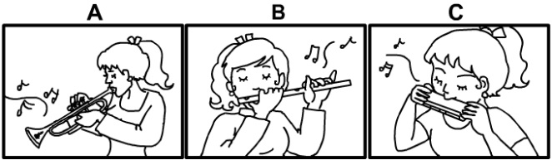

第二部分：基本問答
作答說明：
第4-9題每題均有三個選項，請依據所聽到的對話問句，選出一個最適合的回答。

____ 4.
(A) Oh, it sells milk tea.
(B) Oh, it’s a new movie theater.
(C) It’s OK. I don’t want to sit.
____ 5.
(A) No, what happened to him?
(B) No, I’ve already heard about it.
(C) No, I can’t meet Daniel right now.
____ 6.
(A) She taught us about World War II.
(B) She taught us about numbers.
(C) She taught us about the human body.
____ 7.
(A) Yeah, he often falls asleep during class.
(B) Yeah, he studies till 12 a.m. every night.
(C) Yeah, he works in a coffee shop after school.
____ 8.
(A) Sorry to hear that.
(B) What? Did you read the words on it?
(C) Really? Did you report it to the police?
____ 9.
(A) I am ready to go to the airport now.
(B) Did I receive any mail?
(C) We should throw him a party.

第三部分：言談理解
作答說明：
第10-15題每題均有三個選項，請依據所聽到的對話或短文內容，選出一個最適合的答案。

____ 10.
(A) His grandfather bought it in 1910.
(B) His grandfather made it in 1910.
(C) His grandfather fixed it in 1910.
____ 11.
(A) She’s eating an apple.
(B) She’s eating some spaghetti.
(C) She’s drinking some water.
____ 12.
(A) It’s running with the zebra.
(B) It’s biting the zebra.
(C) It’s caring for the zebra.
____ 13.
(A) Finish the game.
(B) Wash the dishes.
(C) Write something.
____ 14.
(A) He doesn’t have much hair.
(B) His hair grows very fast.
(C) He likes old photos.
____ 15.
(A) In the office before Wednesday.
(B) At the hall by 3:30 p.m.
(C) In the classroom after practice.

