3月國中教育會考英語科聽力測驗模擬試題 (1)

第一部分：辨識句意
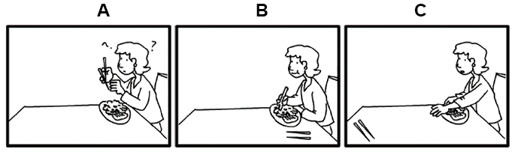
C 1. Jenny can’t reach the chopsticks. They’re too far away.

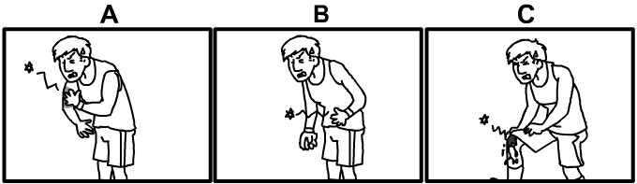
A 2. Paul hurt his arm when he played basketball yesterday.

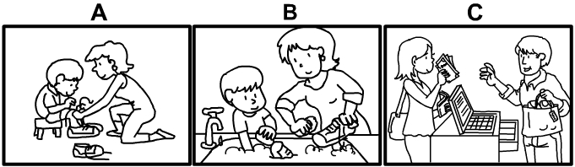
A 3. Vivian helped her son tie his shoes.

第二部分：基本問答
C 4. Trevor is a really humble guy.
(A) Yes, he runs really fast.
(B) Yes, he gets angry easily.
(C) Yes, he is not proud.
A 5. Let’s go to the forest today!
(A) Cool! I love to walk in the woods.
(B) OK, there’s a new movie out today.
(C) Sure, we can do some shopping.
B 6. There are several cookies on the table.
(A) What? Who ate them all?
(B) Good. I’ll have some after lunch.
(C) You’re wrong. Chocolate is not my favorite.
A 7. Are you looking for something?
(A) Yes, I just lost my wedding ring.
(B) Yes, I really enjoy watching movies.
(C) Yes, I have to study for the math test.
C 8. Let’s hold a big party tonight!
(A) OK, let’s spend time alone.
(B) Sure, I feel tired as well.
(C) OK, I’ll invite some people.
C 9. Will the temperature rise this week?
(A) Yes, it will get colder.
(B) Yes, it will stay the same.
(C) Yes, it’s going to get hotter.

第三部分：言談理解
A 10. W: When will the bus get here?
M: I don’t know.
W: Why don’t we take a taxi?
M: Don’t worry. The bus will be here soon.
W: I’m just worried that we might be late for the party.
M: Fine. If the bus doesn’t show up in five minutes, we’ll take a taxi.
Q: What can we say about the woman?
(A) She doesn’t want to wait.
(B) She doesn’t want to go to the party.
(C) She loves to take the bus.
B 11. M: Wow! You got another 100% on the English exam.
W: Yes, I’m proud of myself.
M: I’m bad at English. What are some ways to improve?
W: I can help you tomorrow.
Q: What is the man asking the woman about?
(A) Answers for the English exam.
(B) Some ideas for learning English.
(C) A famous English book.
A 12. M: That was a great museum.
W: Yeah, it was really interesting. I took a lot of photos inside.
M: Me too! We should come again next time.
W: You’re completely right.
M: It’s still early. What do you want to do now?
W: I think we should have a meal.
Q: What does the woman mean?
(A) They should eat something.
(B) They should visit the museum right away.
(C) They should take a picture in front of the museum.
C 13. M: Hi, Susan. Happy birthday!
W: Thanks, Paul!
M: Here, I got you this. Open it!
W: That’s so sweet of you!
Q: What did the man likely just do?
(A) He gave Susan a kiss.
(B) He invited Susan to a party.
(C) He gave Susan a gift.
B 14. M: Did you feed the cat?
W: No, not yet.
M: Can you do it when you get a chance?
W: Sure, no problem. I’ll do it right after I finish my work.
M: Thank you so much. I promise I will pick up my cat as soon as possible.
Q: What will the woman do?
(A) She will ask the man to feed the cat.
(B) She will feed the cat when she can.
(C) She will pick up the cat later.
C 15. Welcome to our radio show! Today, we are going to talk about how to stay healthy. First, it’s important to eat a healthy diet. That means you should eat fruits and vegetables every day. Next, make sure you exercise often. Walking, swimming, or playing sports with your friends are great ways. Finally, remember to get enough sleep. Most people need about eight hours of sleep each night to stay healthy.
Q: What is the speaker mainly talking about?
(A) How to improve your sleep.
(B) How to include exercise in your daily plan.
(C) How to keep a healthy way of living.

