3月國中教育會考英語科聽力測驗模擬試題 (2)

第一部分：辨識句意
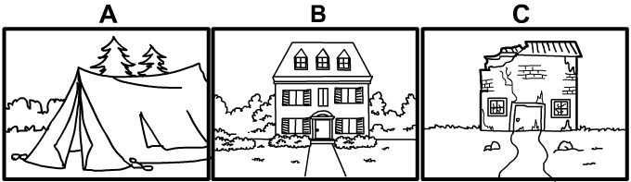
B 1. Jamie lives in a fancy house.
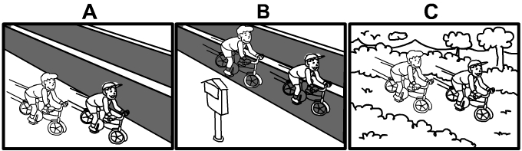
A 2. The children rode their bicycles on the sidewalk.
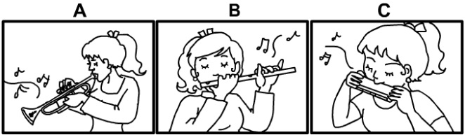
B 3. Gabriella plays the flute very well.

第二部分：基本問答
A 4. What is that stand over there for?
(A) Oh, it sells milk tea.
(B) Oh, it’s a new movie theater.
(C) It’s OK. I don’t want to sit.
A 5. Have you heard the news about Daniel?
(A) No, what happened to him?
(B) No, I’ve already heard about it.
(C) No, I can’t meet Daniel right now.
B 6. What did your teacher teach in math class today?
(A) She taught us about World War II.
(B) She taught us about numbers.
(C) She taught us about the human body.
B 7. Dave is a really hard-working student.
(A) Yeah, he often falls asleep during class.
(B) Yeah, he studies till 12 a.m. every night.
(C) Yeah, he works in a coffee shop after school.
C 8. I found a box of gold pieces at a park next to my neighbor’s house!
(A) Sorry to hear that.
(B) What? Did you read the words on it?
(C) Really? Did you report it to the police?
A 9. The plane leaves at 2 p.m. this afternoon.
(A) I am ready to go to the airport now.
(B) Did I receive any mail?
(C) We should throw him a party.

第三部分：言談理解
B 10. M: Do you see the house over there?
W: Which one? There are a lot of houses.
M: The red one with the tall roof.
W: Oh, I see it now. What about it?
M: My grandfather built it in 1910.
W: Wow! That was a long time ago.
Q: What does the man say about the house?
(A) His grandfather bought it in 1910.
(B) His grandfather made it in 1910.
(C) His grandfather fixed it in 1910.
A 11. M: What are you eating?
W: I’m having a snack.
M: Didn’t you just have spaghetti for lunch?
W: Yeah, but I’m hungry again.
Q: What is the woman probably doing?
(A) She’s eating an apple.
(B) She’s eating some spaghetti.
(C) She’s drinking some water.
B 12. M: What are you watching?
W: A show about lions. Do you want to join me?
M: Sure! Wait … what is the lion doing?
W: It’s attacking the zebra.
M: That’s terrible! Poor zebra …
W: It’s just how nature works.
Q: What can we say about the lion?
(A) It’s running with the zebra.
(B) It’s biting the zebra.
(C) It’s caring for the zebra.
C 13. W: Frank, what are you doing?
B: I’m playing computer games.
W: You know you need to finish your homework before you play games, right?
B: Oh, I totally forgot!
W: Well, you should stop and start your homework now.
B: OK, I will get to it right away.
Q: What will the boy likely do next?
(A) Finish the game.
(B) Wash the dishes.
(C) Write something.
A 14. W: Is the man on the left side of the photo your dad?
M: Yeah, that’s him. The woman on the right side is my sister.
W: I didn’t know your dad had such thin hair.
M: Yeah, I hope I won’t be like that.
Q: What can we say about the man’s father?
(A) He doesn’t have much hair.
(B) His hair grows very fast.
(C) He likes old photos.
A 15. Attention all students. There will be a school talent show next Friday. We hope everyone can join in or come to watch the show. You can sign up for the show at the office before this Wednesday. The talent show will begin at 4 p.m. in the school hall. It will last for about two hours. All students who join the show should arrive at the hall by 3:30 p.m. There will be a final practice. Make sure to invite your family and friends to enjoy the show!
Q: Where can students sign up for the talent show?
(A) In the office before Wednesday.
(B) At the hall by 3:30 p.m.
(C) In the classroom after practice.

