2025年3 月GEPT聽力測驗 解答頁
第一部份 看圖辨義
For questions number 1 and 2, please look at Picture A.

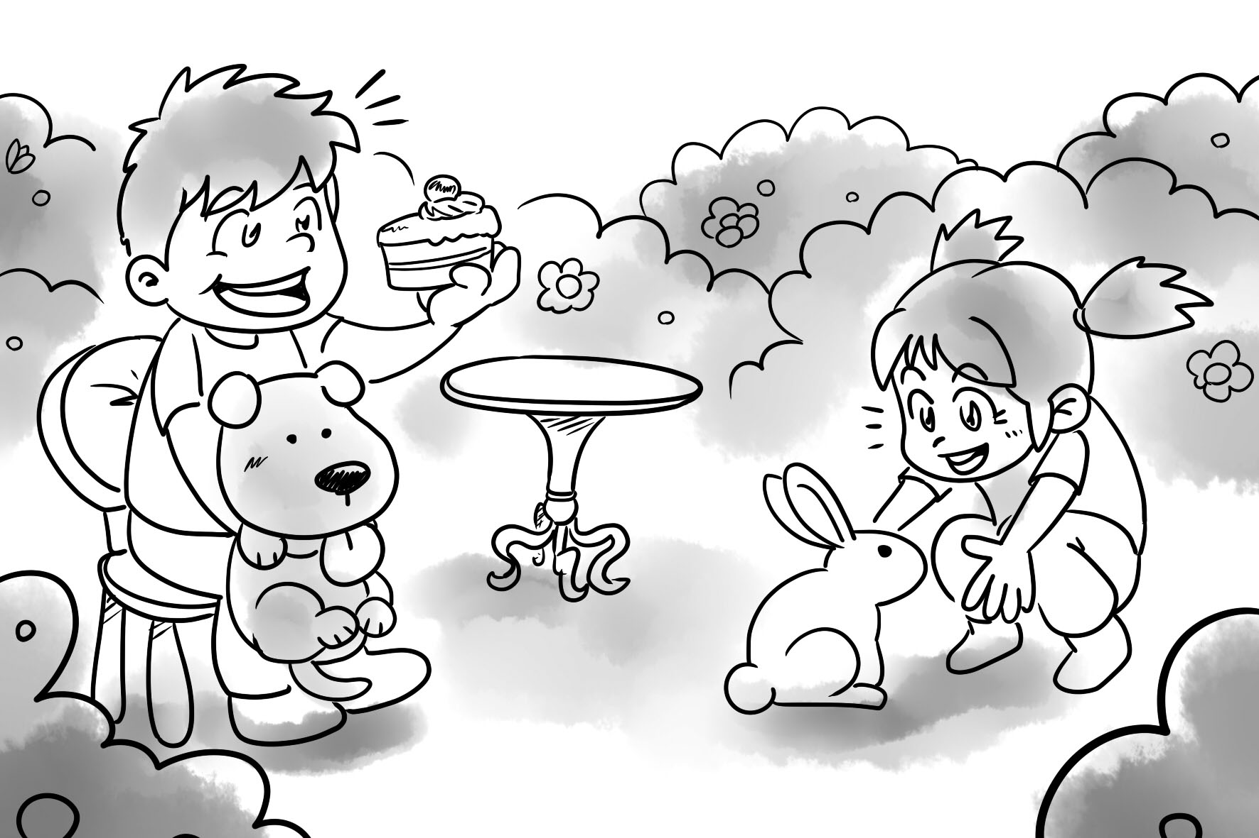
A 1. Where are the boy and the girl?
(A) They are in a garden.
(B) They are in a kitchen.
(C) They are in a bathroom.

C 2. Please look at Picture A again. What is the girl doing?
(A) She is holding a cute dog.
(B) She is feeding the rabbit some cake.
(C) She is playing with her pet rabbit.

For question number 3, please look at Picture B.
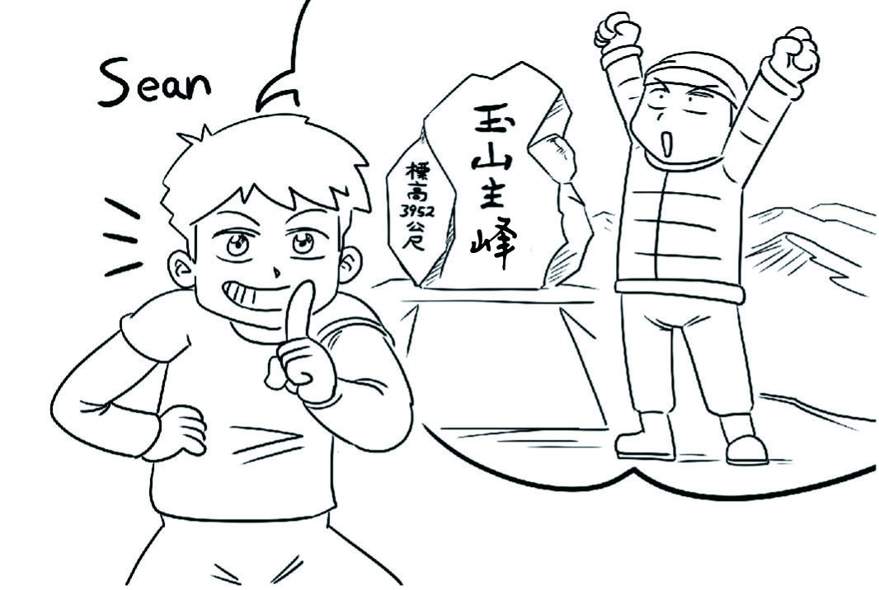．
B 3. What is Sean saying?
(A) “I cleaned a beach last month.”
(B) “I climbed Yushan last month.”
(C) “I climbed a tall tree yesterday.”

For questions number 4 and 5, please look at Picture C.
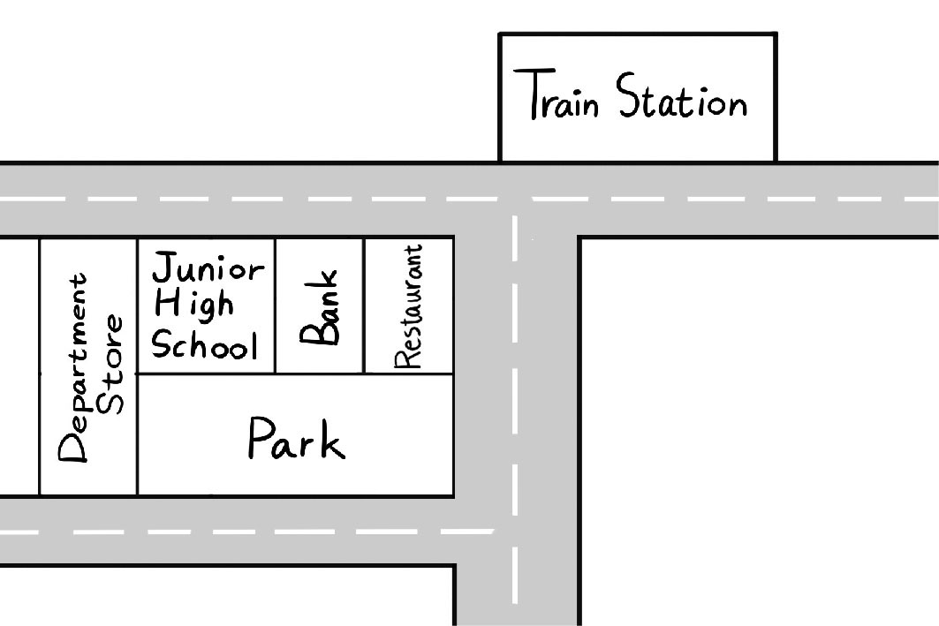
A 4. Where is the junior high school?
(A) It’s behind the park.
(B) It’s between the bank and the restaurant.
(C) It’s in front of the train station.

C 5. Please look at Picture C again. Where is the restaurant?
(A) It’s behind the train station.
(B) It’s between the park and the department store.
(C) It’s beside the bank.

第二部份 問答
A 6. I have to see the doctor on Monday mornings.
(A) I can drive you to the hospital every week.
(B) OK. I can take you to the library.
(C) Sure, we can have lunch now.

C 7. Do you want to take cooking lessons?
(A) Yes, I go to math class once a week.
(B) I can teach you how to paint some pictures.
(C) No, thanks. I’m already very good at it.

B 8. When is the Christmas Eve party?
(A) Prepare a gift for the party, please.
(B) The party is on December 24.
(C) I would like to open your gift.

C 9. I wake up at a quarter to seven in the morning.
(A) You leave the house at 7:15 a.m.? So early!
(B) Hurry up! It is time for school.
(C) I also wake up at 6:45 a.m.

C 10. Is Matt studying English?
(A) Yes, he has a math class.
(B) Please be a good student.
(C) Yes, he is studying hard.

B 11. Have you seen my keys?
(A) No, I didn’t bring any food.
(B) Yes, I saw them on the table.
(C) Sure. I will call you tomorrow.

C 12. Where did you buy that dress?
(A) I will go next time.
(B) It’s very expensive.
(C) I bought it online.

A 13. What is Sarah painting?
(A) It’s a picture of a garden.
(B) Yes, Sarah really knows how to paint well.
(C) No, Sarah is not a painter.

B 14. Jeff’s birthday is July 31.
(A) So, his birthday is in winter?
(B) Let’s buy him a gift!
(C) My birthday is also in April.

B 15. What day is the math test?
(A) You have to study for it.
(B) It’s next Friday.
(C) The math test is at 1 p.m.

第三部份 簡短對話

C 16. W: Do you need any help with your homework, Jimmy?
B: No, thanks. I’ve already finished it.
W: That’s great! What are you going to do now?
B: I think I’ll watch some TV.
W: Don’t stay up too late. You have an early class tomorrow.
B: Don’t worry. I’ll just watch for a little while.
Q: What will Jimmy do next?
(A) Watch TV all night.
(B) Do his homework.
(C) Go to bed soon.

A 17.W: Where are you going?
M: To send some letters.
W: Oh, could you take this for me?
M: What is it?
W: It’s a card for my grandmother.
Q: Where is the man going?
(A) To the post office.
(B) To the library.
(C) To a new restaurant.

B 18. M: What did you do today?
W: I stayed inside.
M: The temperature was quite low today.
W: Yeah. Luckily, it didn’t rain, though.
M: I still wore a coat in my home.
W: Right, me too.
Q: What can we say about the weather today?
(A) It’s wet.
(B) It’s cold.
(C) It’s windy.

B 19. G: My father works as a doctor, and my mother is a high school teacher.
B: That’s cool! Do you have any brothers or sisters?
G: Yes, I have an older brother.
B: What does he do?
G: He’s still in college. And he is studying engineering.
B: That sounds interesting.
Q: What does the girl’s mother do?
(A) She works in a college.
(B) She works in a school.
(C) She works in a hospital.

B 20. M: You look different today.
W: I’m wearing brighter colors.
M: Is that a new dress?
W: Yeah, I’m trying out a new style.
M: You look great.
Q: What does the man mean?
(A) The woman’s skin looks better.
(B) The woman’s clothes look special.
(C) The woman should wear dark clothes.

C 21. W: Have you ever been to that new restaurant downtown?
M: Yes, I went there last weekend. The food was great!
W: I heard it’s always crowded.
M: It was, but we booked a table.
W: I might try it this weekend. What did you order?
M: We had the steak and some spaghetti. Both were delicious.
Q: What do we learn from this conversation?
(A) The woman has been to the new restaurant.
(B) The man waited in line at a restaurant last weekend.
(C) The new restaurant is really popular.

B 22. W: Which dress is better? I can’t decide.
M: The blue one looks better than the red one.
W: Do you think so? I like them both.
M: Well, the red one is less expensive.
W: I am going to buy these two dresses.
M: Are you sure about that?
Q: What does the woman mean?
(A) She wants the man to pay for the dress.
(B) She will buy both of the dresses.
(C) She will only buy a red dress.

A 23.W: Are you ready to go?
M: Yes, let’s go to the restaurant.
W: OK, let me put on my jacket.
M: How should we get there?
W: Let’s take the bus.
Q: What are the speakers going to do?
(A) Eat a meal.
(B) Shop for clothes.
(C) Buy some books.

C 24. W: Did you finish packing your bag?
M: Yes, I’m ready.
W: Did you remember to pack some socks?
M: Yes, I brought six pairs.
W: All right, good. We can leave now.
M: OK. I’ll bring my bag to the car.
Q: How many socks did the man bring?
(A) Three.
(B) Six.
(C) Twelve.

B 25.W: Let’s hike to the top of the mountain.
M: I don’t have the energy to do that.
W: Well, what do you want to do?
M: Let’s sit down for a few minutes.
W: All right. We can do that.
Q: What does the man mean?
(A) He is full of energy.
(B) He is tired.
(C) He is ready to hike.

第四部份 短文聽解

C 26. Please look at the following three pictures. Listen to the following short talk. What did Claudia do today?

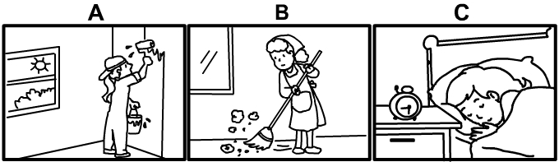
Claudia is acting very lazy today. Her mother asked her to paint the walls and sweep the floor. She planned to get up early to do these things today. She usually works hard. However, she forgot to set the alarm and slept all day.

B 27. Please look at the following three pictures. Listen to the following short talk.
What is the weather like for Mike right now?
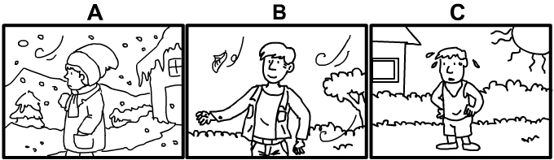
Mike lives in Russia. He would like to move to Southeast Asia to enjoy the warm sun. It’s not winter now, so it’s not snowing in Russia. However, Mike is wearing a jacket because the weather today is windy. A few leaves are blowing around in the air.

C 28. Please look at the following three pictures. Listen to the following short talk.
What DIDN’T Michelle do today?
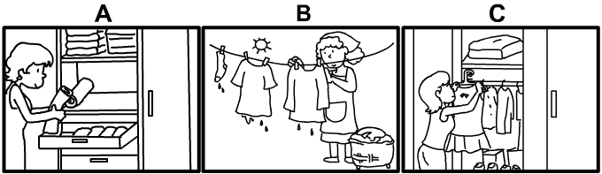
Michelle did a lot of work around the house today. She washed the clothes. Then she hung them up to dry outside. She put away the clean, dry towels in the drawer. She felt tired after she did all of this work, so she sat down.

A 29. Please look at the following three pictures. Listen to the following message.
What is happening in Andy’s home right now?
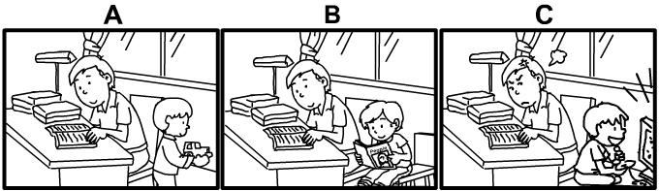
Andy is working from home today. He’s reading something at his desk. Andy’s son doesn’t have school today. He’s also at home with Andy. Andy’s son used to be very noisy at home. However, right now he’s playing quietly. Andy feels very proud of his son.

C 30. Please look at the following three pictures. Listen to the following short talk. Which picture shows Elsie’s mother?
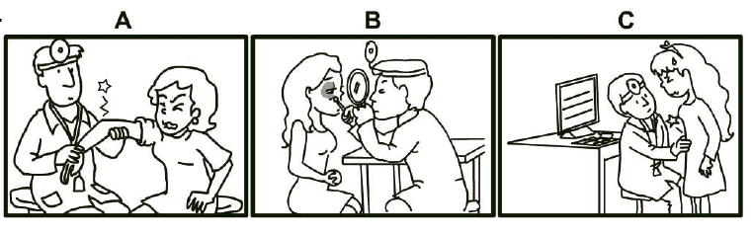
Elsie went to the hospital with her family. Her mother had a stomachache. Her naughty brother hurt his eye. She had a pain in her arm. Her father will take them for another visit next week.

