2025年3月GEPT聽力測驗（試題版）
第一部份 看圖辨義

For questions number 1 and 2, please look at Picture A.
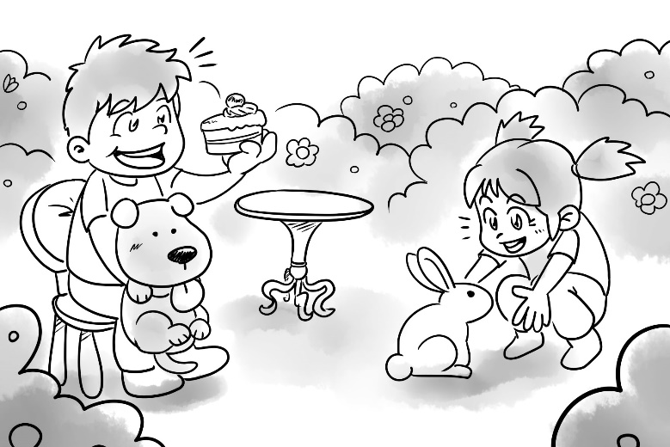

For question number 3, please look at Picture B.
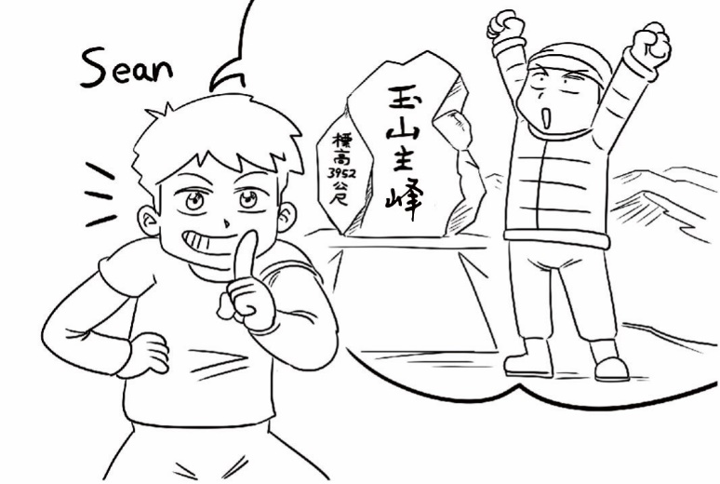

For questions number 4 and 5, please look at Picture C.
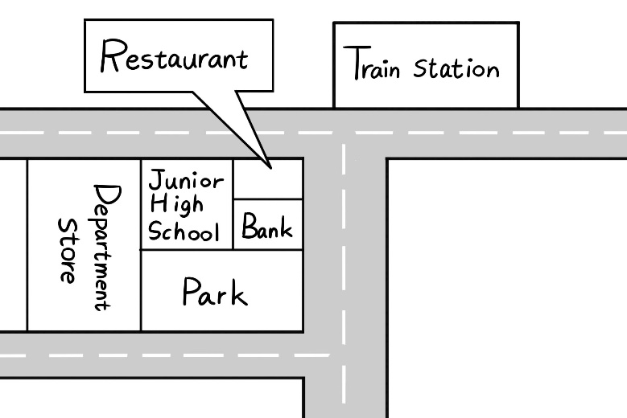

第二部份 問答

6.
(A) I can drive you to the hospital every week.
(B) OK. I can take you to the library.
(C) Sure, we can have lunch now.

7.
(A) Yes, I go to math class once a week.
(B) I can teach you how to paint some pictures.
(C) No, thanks. I’m already very good at it.

8.
(A) Prepare a gift for the party, please.
(B) The party is on December 24.
(C) I would like to open your gift.

9.
(A) You leave the house at 7:15 a.m.? So early!
(B) Hurry up! It is time for school.
(C) I also wake up at 6:45 a.m.

10.
(A) Yes, he has a math class.
(B) Please be a good student.
(C) Yes, he is studying hard.

11.
(A) No, I didn’t bring any food.
(B) Yes, I saw them on the table.
(C) Sure. I will call you tomorrow.

12.
(A) I will go next time.
(B) It’s very expensive.
(C) I bought it online.

13.
(A) It’s a picture of a garden.
(B) Yes, Sarah really knows how to paint well.
(C) No, Sarah is not a painter.

14.
(A) So, his birthday is in winter?
(B) Let’s buy him a gift!
(C) My birthday is also in April.

15.
(A) You have to study for it.
(B) It’s next Friday.
(C) The math test is at 1 p.m.

第三部份 簡短對話

16.
(A) Watch TV all night.
(B) Do his homework.
(C) Go to bed soon.

17.
(A) To the post office.
(B) To the library.
(C) To a new restaurant.

18.
(A) It’s wet.
(B) It’s cold.
(C) It’s windy.

19.
(A) She works in a college.
(B) She works in a school.
(C) She works in a hospital.

20.
(A) The woman’s skin looks better.
(B) The woman’s clothes look special.
(C) The woman should wear dark clothes.

21.
(A) The woman has been to the new restaurant.
(B) The man waited in line at a restaurant last weekend.
(C) The new restaurant is really popular.

22.
(A) She wants the man to pay for the dress.
(B) She will buy both of the dresses.
(C) She will only buy a red dress.

23.
(A) Eat a meal.
(B) Shop for clothes.
(C) Buy some books.

24.
(A) Three.
(B) Six.
(C) Twelve.

25.
(A) He is full of energy.
(B) He is tired.
(C) He is ready to hike.

第四部份 短文聽解

26.
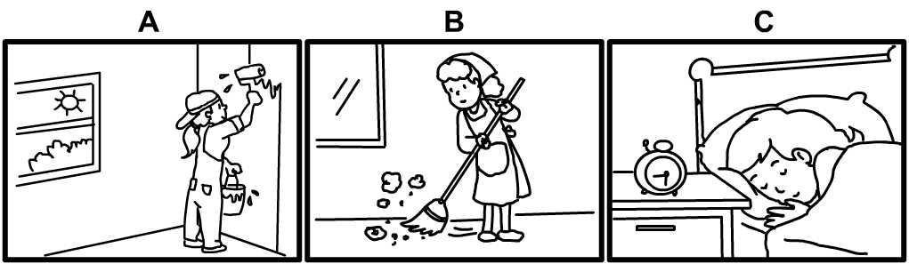

27.
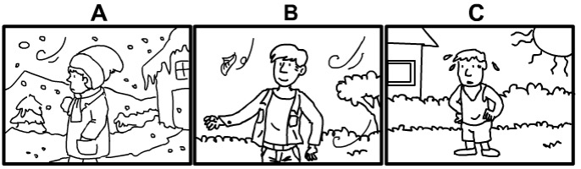

28.
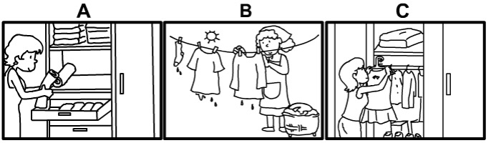

29.
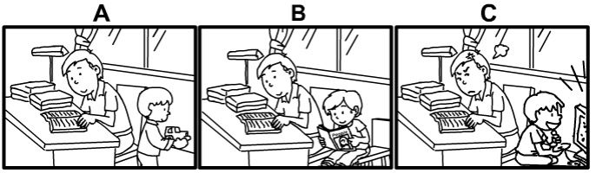

30.


