March 2025 Review Time

Unit | Date | Question Type
U1 | 03/03 | Circle the correct word
U1 | 03/04 | Dictation
U2 | 03/06 | Circle the correct word
U2 | 03/07 | Phonics
U4 | 03/11 | Sentence Writing
U5 | 03/13 | Sentence Writing
U5 | 03/14 | Dialogue Comprehension
U7 | 03/20 | Translation Exercise
U7 | 03/21 | Dictation
U8 | 03/24 | Dictation
U8 | 03/25 | True or False Questions
U10 | 03/27 | Choose the best picture
U10 | 03/28 | Crossword Puzzle

Unit 1
03/03
請圈選出正確答案。
- Archer and Carl grew (a. out / b. up) together, and they’re still close after all these years.
- My dog is (a. friendlier / b. friendly) than my cat. My cat always ignores me!
- Selena wanted to paint the room yellow, but her husband didn’t (a. agree / b. call). He liked blue.

Answers: 1. b 2. a 3. a

03/04
短句聽寫：聽完句子之後，請寫出正確的答案。
1. Reese ___________________________________.
2. Nicholas ________________________________________.

Answers:
1. Reese dreams of buying a car when she saves enough money.
2. Nicholas was walking to school when he saw an old friend.

Unit 2
03/06
請圈選出正確答案。
- A: What’s our plan for this weekend?
B: How about (a. go / b. going) to the beach for a picnic?
- Ellis finished his work, but (a. the other / b. others) are still busy.
- There was a (a. serious / b. perfect) earthquake last night. Many people lost their homes and families.

Answers: 1. b 2. b 3. a

03/07
以下畫底線的母音，哪些跟 about 的 a 有相同 [4] 的發音？
serious experience
even negative
perfect terrible

Answers: serious; negative; terrible

Unit 4
03/11
請依提示用介系詞改寫句子。
- Meredith read her son stories before he went to bed. (to)
→ ____________________________________________________.
句子重組：將下列詞組排列成正確的句子。
- study / didn’t pass / for the exam, / so he / John didn’t / enough
____________________________________________________.

Answers:
- Meredith read stories to her son before he went to bed.
- John didn’t study enough for the exam, so he didn’t pass.

Unit 5
03/13
- 請合併以下兩句，並將其改寫為間接問句：
Maggie doesn’t know it.
Why didn’t her friend show up to the party?
____________________________________________________.

- 句子重組：將下列詞組排列成正確的句子。
learned about / was surprised / death / when he / the famous singer’s / Frank
____________________________________________________.

Answers:
- Maggie doesn’t know why her friend didn’t show up to the party.
- Frank was surprised when he learned about the famous singer’s death.

03/14
簡短對話：請聽一段對話和一個相關的問題後，再從選項中選出一個最適合的答案。
- (A) He’ll turn on the lamp on his desk.
(B) He’ll take a rest and have some snacks.
(C) He’ll borrow notes from the woman.

- (A) He lost his bag at the airport.
(B) He has to buy a new bag.
(C) He has to pay extra for his bag.

以下放解答頁：
- W: Hey, what are you doing?
M: I’m studying for my test tomorrow.
W: Well, you need more light to read. It’s getting dark outside.
M: You’re right. Thanks!
Q: What will the man do next?

- M: How much can I bring in my bag for the flight?
W: The maximum is 20 kilograms. Anything over that will cost extra.
M: Could you check its weight for me?
W: Sure! Let’s see ... your bag is 22 kilograms.
Q: What might be true about the man?

Answers: 1. A 2. C

Unit 7
03/20
引導式翻譯：請依本課的 Word Power 和 Magic Box 內容填入翻譯。
- Katy 在她的日曆上標記了音樂活動的日期。
Katy marked the date of the music _______ on her calendar.
- Leo 僱了一名導遊來帶他參觀城市並介紹歷史。
Leo hired a guide to _______ him _______ the city and explain its history.
- David 每天打掃，保持房子井然有序。
David always keeps the house _______ _______ by cleaning every day.

Answers: 1. event 2. show; around 3. in; order

03/21
短句聽寫：聽完句子之後，請寫出正確的答案。
1. The _______________________________________.
2. The _______________________________________.

Answers:
1. The basic rules of the game are easy to understand.
2. The train might be late because of the storm.

Unit 8
03/24
短句聽寫：聽完句子之後，請寫出正確的答案。
1. Cathy _________________________________.
2. The children ___________________________________.

Answers:
1. Cathy studied in France for two years to learn French.
2. The children played with the sand on the beach.

03/25
True (T) or False (F)
- People can only see Vietnamese-style buildings in Hoi An.
- Da Nang is far from the sea.
- French culture still influences Vietnam to this day.
- The Da Nang Cathedral is famous for its pink walls.

Answers: 1. F 2. F 3. T 4. T

Unit 10
03/27
聽句辨圖：選出符合句子描述的圖片。
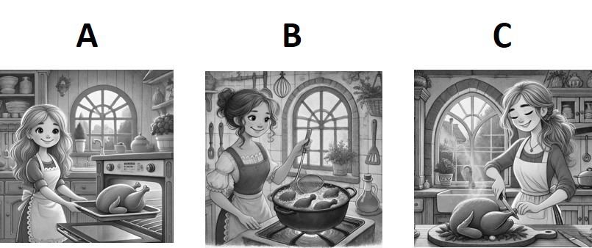
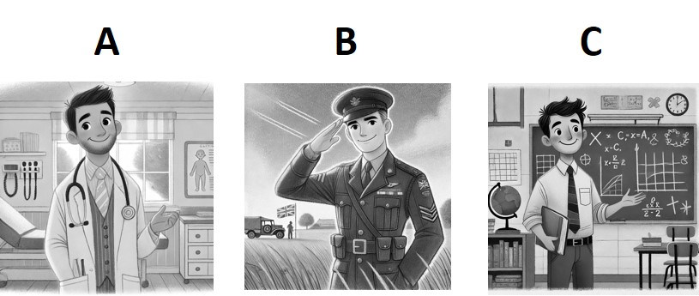

以下放解答頁：
- Adele invited her friends to have dinner at her house. She is frying chicken in the kitchen.
- Alan used to be a doctor. However, he now serves in the army as a soldier.

Answers: 1. B 2. B

03/28
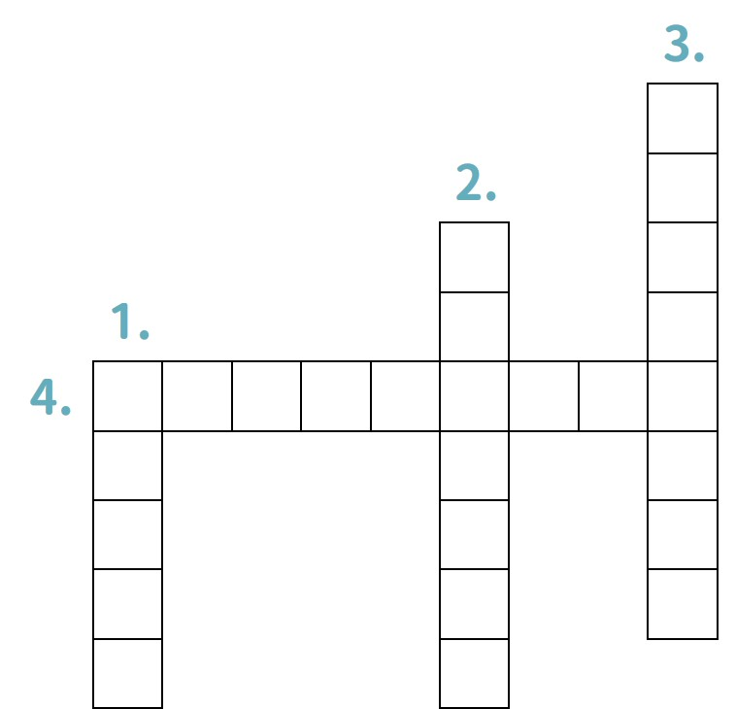
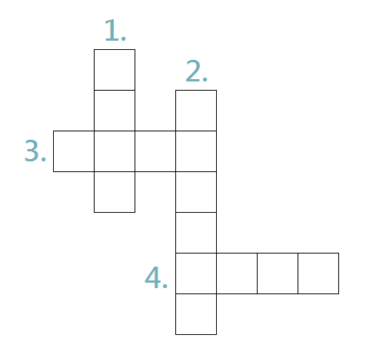
縱橫字謎
DOWN:
- happening every day
- to get something
- you were born and grew up in this place

ACROSS:
- experiencing troubles, especially with money

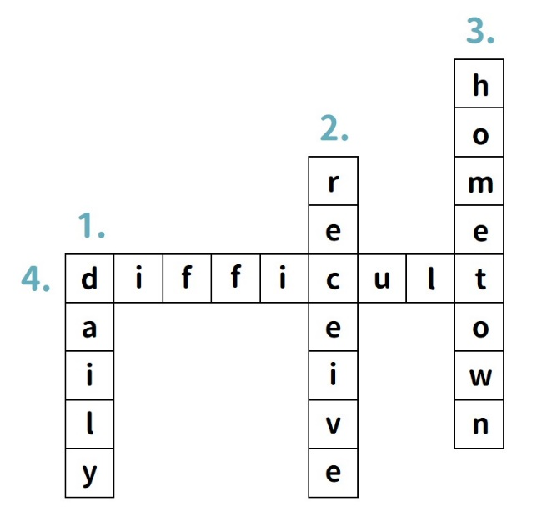
Answer:

